Installing Tizen Studio for RT

To install the Tizen Studio for RT:

1. Accept the software license. The license contains important legal notices for using the Tizen Studio. Read the complete agreement, and click Accept only if you agree with the license statement: 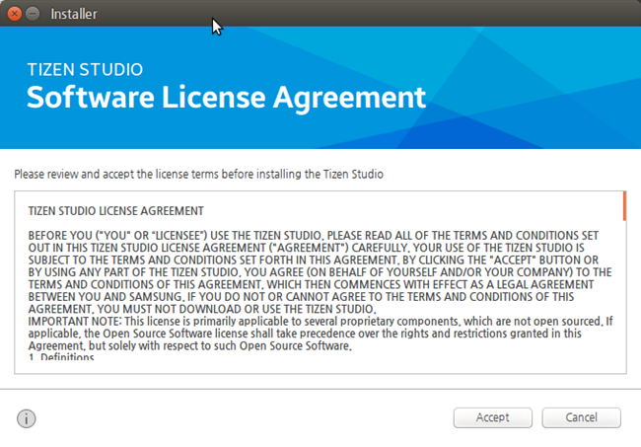
2. Configure the installation directory. The Tizen Studio for RT and its data directory are installed in the location specified in the Installation Settings step. To change the directory, click the ... button and specify a new directory. If the new directory is valid, click Install: 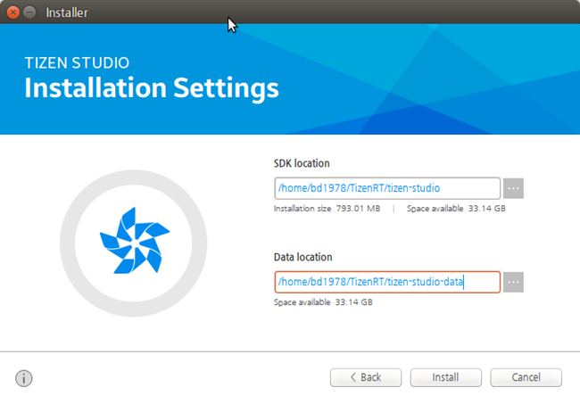
3. Install the Tizen Studio for RT. After you click Install, the installer installs the required packages and tools in the specified directory. You can monitor the installation process or cancel the installation. The installation process is completed in a few minutes, unless you cancel it.
4. Install additional tools. After the installation is finished, you can close the installer by clicking Finish: 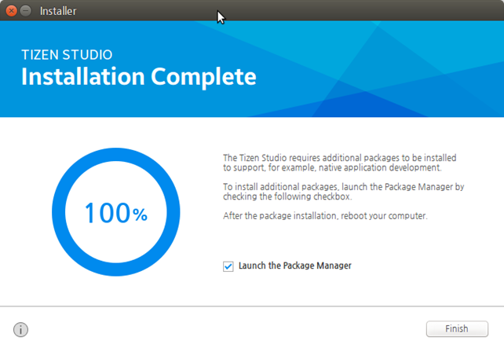 If you want to install additional platforms and tools, launch the Package Manager by selecting the Launch the Package Manager checkbox before clicking Finish. Through the Tizen Studio Package Manager, you can install and update additional tools. For more information on the Package Manager, see [Updating Tizen Studio](https://developer.tizen.org/development/tizen-studio/download/installing-tizen-studio/updating-tizen-studio) and [Configuring the Package Manager](https://developer.tizen.org/development/tizen-studio/download/configuring-package-manager). 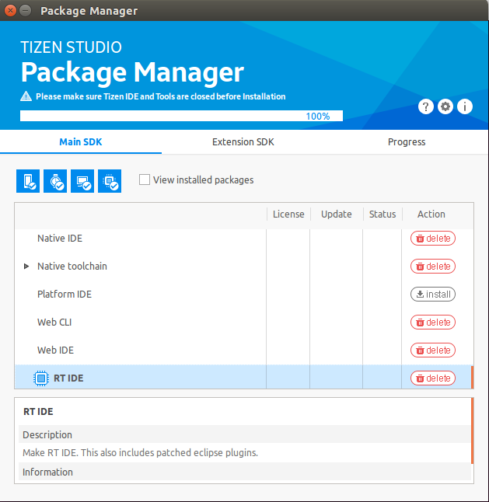
5. Launch the Tizen Studio for RT. After launching the Tizen Studio for RT from the application shortcut, select a workspace for your development: 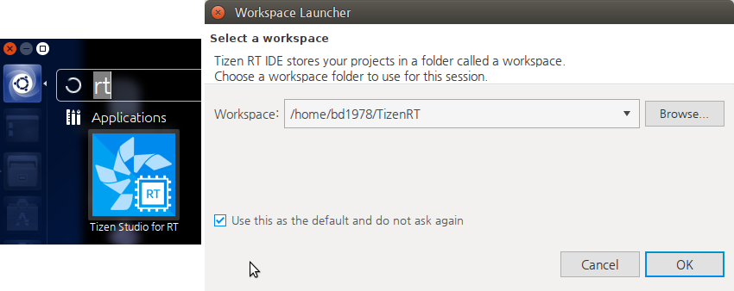

The following figure illustrates on launching the Tizen Studio for RT:

